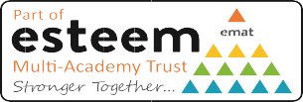
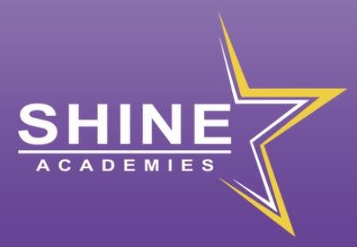
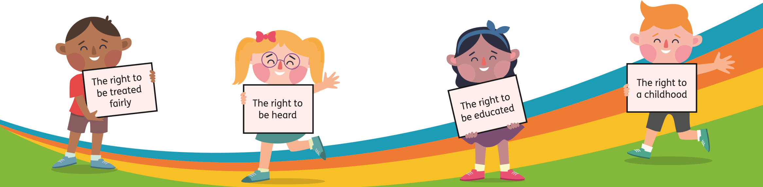
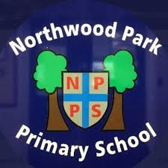


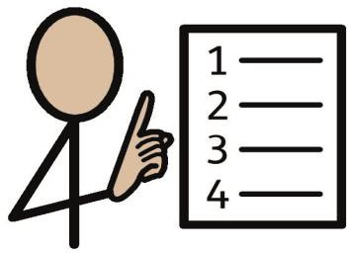
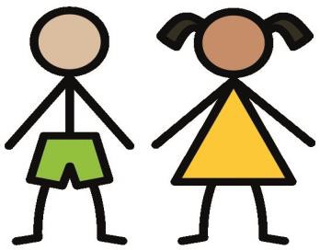

Safeguarding Policy for Children
January 2025

Safeguarding at Northwood Park Primary School
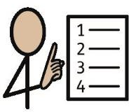
Our school has a safeguarding policy for staff, families and governors. This child friendly policy is designed for you.
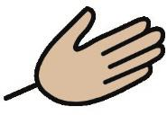
It will help you decide what could be a problem and where to get help. You might want to talk to someone about something that is upsetting you.
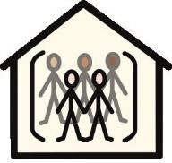
We have people in school who are trained to help you.
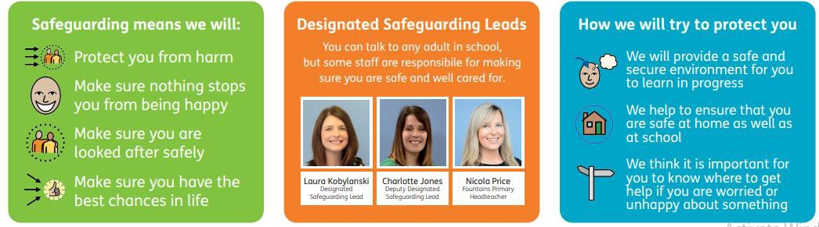
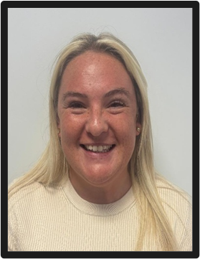
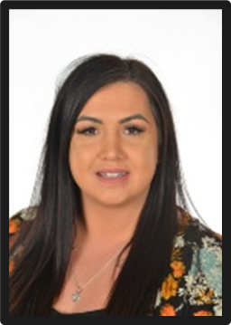
It is important that you know where to get help if you are worried or unhappy about something.
Mrs K Webb
Deputy
Safeguarding lead
Mrs T Bentley
Safeguarding lead

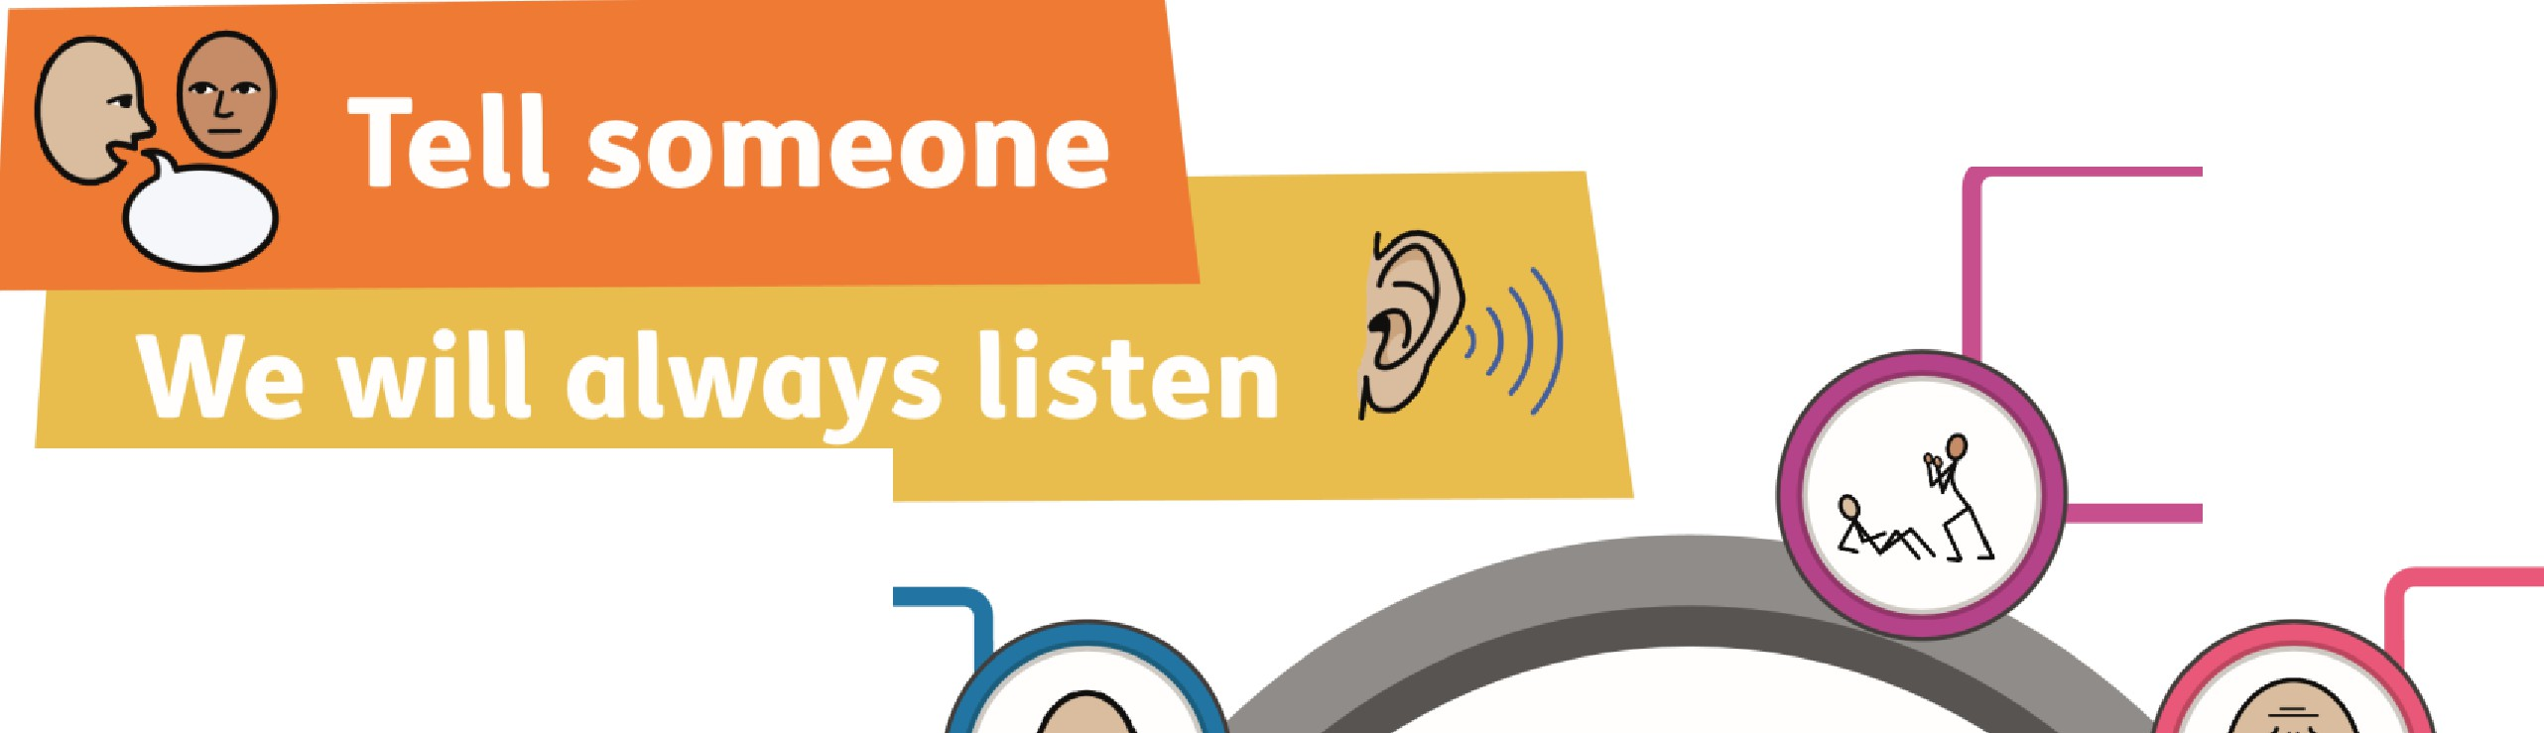
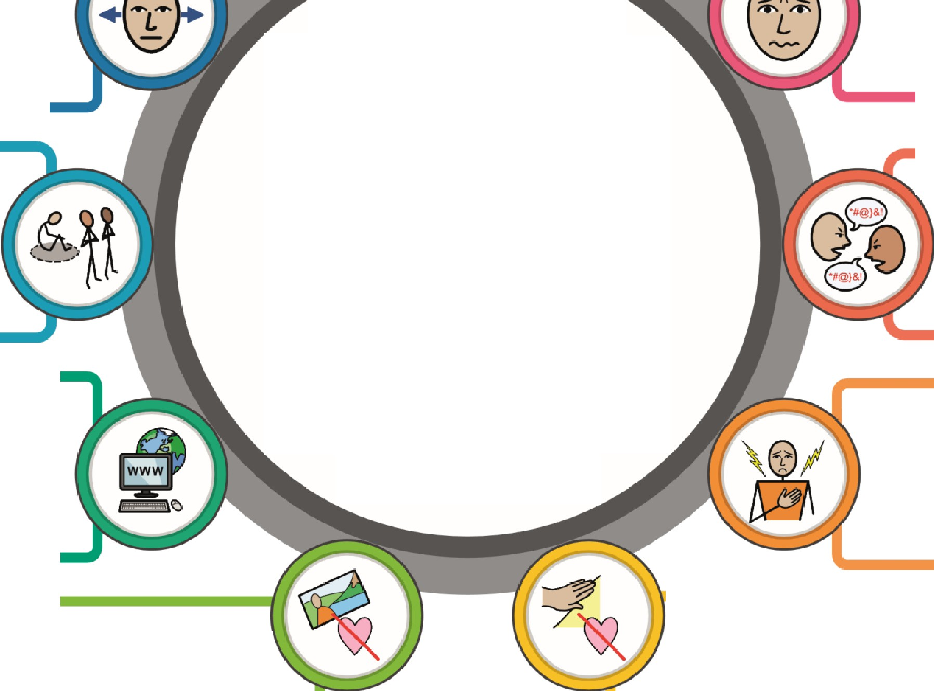
Is somebody bullying you?

Tell someone so we can help
Is somebody trying to make you do something you don't want to?
You can tell your:
If somebody doesn't take proper care of you and you feel lonely, hungry or neglected
- Teacher
- Support Staff
- Wellbeing Team
  - Headteacher
- Designated Safeguarding
Lead
Has somebody you don't know tried to talk to you online?
Anyone at School

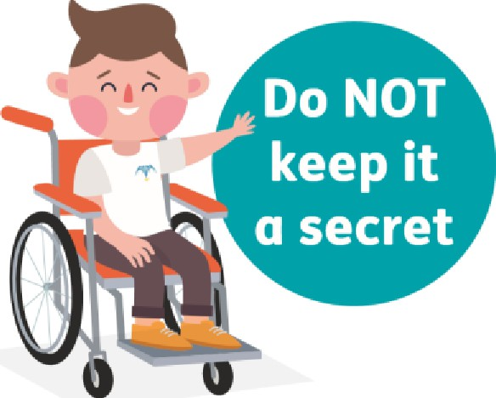
Has somebody shown you pictures you

Has somebody touched you in a way that you don't like?
don't like?
Has somebody said anything that makes you feel sad, scared or worried?

If somebody shouts, threatens, hits or hurts somebody you love whilst you are around

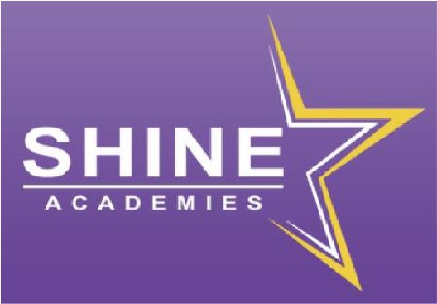
Has somebody hurt you?

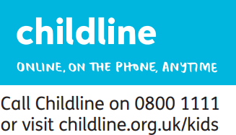
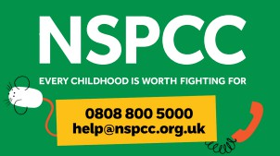
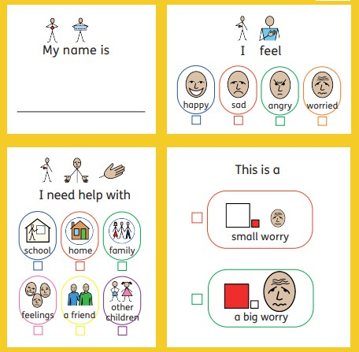
Other places that may be able to help you
Child Safeguarding Form

